**Annual Balloon Festival**

**Cardboard Boat Regatta**

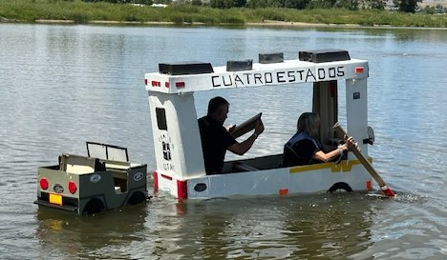

**Date: Saturday, August 2nd, 2025**

**Where: Loudy-Simpson Park pond**

**When: 1:30pm – 2:30pm – Registration at 12:30PM**

**Requirements:**

* **Team sizes are 2 – 4 members**
* **Every team member must complete a waiver to participate.**

Rules and Regulations

* Rule One: Have fun! All entries must have eye appeal. Unique boat designs, creativity and team outfits are encouraged.
* Rule Two: Cardboard is the only structural material to be used.
* Rule Three: Glues, paint and caulking will be permitted, but no membrane materials, such as plastic sheeting or fiberglass will be allowed. No asphalt-based coating may be used, i.e.: driveway sealer, etc. **Duct tape or tapes of any kind may be used but CANNOT be used on the outside of the hull (the portion of the boat submerged in water**). If the judge determines that tape has been used on the outside of the boat the boat can still race but will not be considered for the fastest time award
* Rule Four: Boats can be propelled using hands or paddles. Paddles are to be made of cardboard and follow the same construction rules as the boat. All participants must remain in the boat the entire time to be considered for fastest time award.
* Rule Five: All boats will be closely inspected prior to the race. **THE RACE JUDGE HAS FINAL SAY ON IF A BOAT QUALIFIES UNDER THE ABOVE RULES.**
* Rule Six: All participants must wear a life vest during the competition.

Boats will be called two at a time to enter the pond and race. Boats and people are to remain in the grass area until called to race.

$2,000 Cash prizes will be awarded.

Categories:

1. Fastest Finish Time – BOAT INTACT AND ALL PARTICIPANTS INSIDE THE BOAT.
2. Best Overall Design
3. Titanic Award (most spectacular sinking)